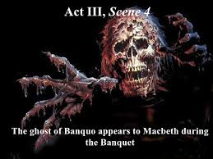


Scene 2: Macbeth tells his wife that he has killed Duncan- he is already suffering as a result. He refuses to take the daggers back to Duncan’s chambers. Lady Macbeth does it herself, and tells Macbeth to pull himself together.

Scene 3: Macbeth’s porter imagines himself keeper of Hell’s gate. He jokes with Macduff about the effects of too much drink.
Macduff discovers Duncan’s body and Lady Macbeth pretends to be very concerned. Malcolm and Donalbain- Duncan’s sons are told about his murder and Macbeth defends his killing of the guards. Lady Macbeth faints and Duncan’s sons flee –Malcolm to England, Donalbain to Ireland.

Scene 1: Banquo is highly suspicious of Macbeth, but is cheered by the witches’ predictions for his own descendants. Macbeth requests his presence at tonight’s feast.
Macbeth claims that Duncan’s sons are spreading vicious rumours. He instructs the murderers to kill Banquo and Fleance.

Scene 4: Ross and an old man talk about the darkness and unnaturalness of events the mirror Duncan’s murder.
Macduff suspects Malcolm and Donalbain- Duncan’s sons of the murder, because they have run away. He decides not to go to watch Macbeth be crowned.

ACT 3
Scene 4: Macbeth welcomes his guests to the banquet, but soon hears news of Fleance’s escape. He sees Banquo’s ghost, sitting in his place at the feast, but he recovers his composure and proposes a toast. The ghost re-enters. He busts into violent language and Lady Macbeth orders the lords to leave.
Macbeth decides to visit the witches. He will now kill anyone who stands in his way.

Scene 5: Hecate is angry with the witches for dealing with Macbeth without her. She promises magic to bring him down. 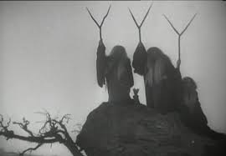

Scene 6: Lennox talks of Macbeth’s guilt and hints that Macbeth might be planning to murder Malcolm, Donalbain and Fleance.
A lord tells him that Malcolm has been warmly welcomed in England and that Macduff has asked the king of England to raise an army against Macbeth.

Scene 1: Banquo and Macbeth talk- Banquo tells him he has dreamed of the witches- he will not be swayed into betraying Duncan. He and Fleance leave.

Macbeth imagines a bloody dagger in front of him- both a warning and an invitation. His mind is full of evil images. He goes off to kill Duncan.

Scene 2: Macbeth has fought bravely against Norway and the Thane of Cawdor with his friend Banquo.
The Thane of Cawdor is to be executed and King Duncan will give his title to Macbeth
Scene 3: Banquo is killed, but Fleance escapes.

Scene 2: Lady Macbeth is troubled, but advises Macbeth not to brood- it doesn’t’ work- he envies Duncan the peace of death.
He hints to her that terrible deeds will be performed that night.

ACT 1
Scene 7: Macbeth can’t make up his mind about killing Duncan. He considers various reasons not to: 1) if Macbeth becomes king, the same could happen to him. 2) He’s the king- Macbeth should protect him, not kill him. 3) He’s a good king and people will respond badly to his death. He decides not to do it, but Lady Macbeth persuades him through emotional blackmail.

Scene 1: The Three Witches plan to meet with Macbeth as the play opens.

ACT 2
Scene 3: The Three Witches greet Macbeth as: 1. Thane of Glamis 2. Thane of Cawdor 3. The King
They also greet Banquo, telling him his children will be kings.
They vanish.

Scene 4: Macbeth is greeted by Ross and Angus- King Duncan is to give Macbeth the title of Thane of Cawdor. The second witch’s prediction has already come true! Macbeth wonders what he has to do to make the third prediction come true- nothing, maybe. But Duncan enters and announces that his son Malcolm is to be King. He also says he will spend the night at Macbeth’s castle in Dunsinane. Fate seems to be playing into Macbeth’s hands!

Scene 5: Lady Macbeth reads a letter from her husband, telling her of the witches’ predictions. When Macbeth arrives, Lady Macbeth persuades him they must kill Duncan.



Scene 6: Lady Macbeth greets Duncan and disguises her evil intentions with smiles.



Scene 2: Macduff’s wife is comforted by Ross- she’s angry with her husband for going abroad. Then, the murderers enter and kill Macduff’s son and pursue Lady Macduff off stage.

Scene 1: The witches chant as they prepare a disgusting brew. Macbeth demands answers- no matter the consequences.
Three apparitions give their advice:
1. Beware Macduff 2. No man born naturally can harm him 3. He’ll be safe until Birnham Wood comes to Dunsinane.
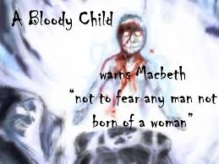
Macbeth demands to know more, and they show him a procession of eight kings and Banquo.
Macbeth resolves to kill Macduff’s family.

ACT 4
Scene 6: Malcolm issues orders for battle!

Scene 5: Seyton brings news of Lady Macbeth’s death. He feels that life is futile.
A messenger tells him that Birnam Wood is moving towards Dunsinane! Macbeth determines to die fighting.
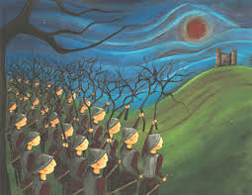

Scene 4: Malcolm orders the soldiers to cut branches from Birnham Wood for camouflage.
Macbeth seems to have lost any sense of fear.

Scene 3: Macbeth recalls the apparitions’ predictions. He is furious- he knows the coming battle will make or break him. He determines to fight to the death.
The Doctor says he can’t sure his mental illnesses.

Scene 2: News comes to Macbeth that Malcolm, Macduff, Siward and the English army approach. Macbeth is troubled- his own soldiers obey him only out of fear.

Scene 1: A servant and a doctor observe Lady Macbeth sleepwalking- she is trying to wash blood from her hands. She appears to be talking about the past murders of Duncan, Lady Macduff and Banquo.

ACT 5
Scene 3: Macduff urges Malcolm to go to Scotland’s defence- but Malcolm is suspicious of him. He decides to trust him and says he is ready to invade Scotland. Ross tells Macduff his family is well- he avoids telling the awful truth, but then comes out with the news that they have been slaughtered.
Macduff is grief-stricken, and Malcolm declares that now is the time to overthrow Macbeth.

Scene 7: Macbeth kills Young Siward and boasts that no man born of woman can kill him.
Macduff will fight only with Macbeth.
Siward invites Malcolm to enter the surrendered castle.

Scene 8: Macbeth faces Macduff and boasts that no man naturally born can kill him- but Macduff reveals his own Caesarean birth. At first Macbeth refuses to fight, but Macduff threatens that he will be exhibited in captivity. Macbeth is killed.


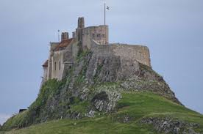
Scene 9: Siward hopes that his son died bravely. Macduff displays Macbeth’s severed head.
Malcolm invites everyone to his coronation at Scone.

